EXPERIMENT – 5

Software Engineering Lab - Class Diagram (repository-context-aware verification layer)
Aim: To create a Class Diagram for ContextGuard — a repository-context-aware verification layer for reliable LLM-based code review

Prerequisite:
- Basic understanding of functionality for the system to be designed
Outcome: After successful completion of this experiment students will be able to
- Identify the various Classes and their association with each other.
- Identify the various attributes and functionality of individual classes.

Theory:
What is Data modeling?
Data modeling in software engineering is the process of creating a data model for an information system by applying formal data modeling techniques.

Data modeling is a process used to define and analyze data requirements needed to support the business processes within the scope of corresponding information systems in organizations. Therefore, the process of data modeling involves professional data modelers working closely with business stakeholders, as well as potential users of the information system.

There are three different types of data models produced while progressing from requirements to the actual database to be used for the information system.^{[2]} The data requirements are initially recorded as a conceptual data model which is essentially a set of technology independent specifications about the data and is used to discuss initial requirements with the business stakeholders. The conceptual model is then translated into a logical data model, which documents structures of the data that can be implemented in databases. Implementation of one conceptual data model may require multiple logical data models. The last step in data modeling is transforming the logical data model to a physical data model that organizes the data into tables, and accounts for access, performance and storage details. Data modeling defines not just data elements, but also their structures and the relationships between them.^{[3]}

Data modeling techniques and methodologies are used to model data in a standard, consistent, predictable manner in order to manage it as a resource. The use of data modeling standards is strongly recommended for all projects requiring a standard means of defining and analyzing data within an organization, e.g., using data modeling:

- to assist business analysts, programmers, testers, manual writers, IT package selectors, engineers, managers, related organizations and clients to understand and use an agreed semi-formal model the concepts of the organization and how they relate to one another
- to manage data as a resource
- for the integration of information systems
- for designing databases/data warehouses (aka data repositories)

Data modeling may be performed during various types of projects and in multiple phases of projects. Data models are progressive; there is no such thing as the final data model for a business or application. Instead a data model should be considered a living document that will change in response to a changing business. The data models should ideally be stored in a repository so that they can be retrieved, expanded, and edited over time. Whitten (2004) determined two types of data modeling:

- Strategic data modeling: This is part of the creation of an information systems strategy, which defines an overall vision and architecture for information systems is defined. Information engineering is a methodology that embraces this approach.
- Data modeling during systems analysis: In systems analysis logical data models are created as part of the development of new databases.
Data modeling is also used as a technique for detailing business requirements for specific databases. It is sometimes called database modeling because a data model is eventually implemented in a database.
  - How to identify the Classes for a scenario.
For a scenario, Classes can be identified using these six class selection characteristics
    - Retained information
      - Information must be remembered about the system over time
    - Needed services

      - Set of operations that can change the attributes of a class
    - Multiple attributes
      - Whereas, a single attribute may denote an atomic variable rather than a class
    - Common attributes
      - A set of attributes apply to all instances of a class
    - Common operations
      - A set of operations apply to all instances of a class
    - Essential requirements
      - Entities that produce or consume information

  - Guidelines for selecting appropriate classes and deciding their attributes and functions.
Attributes and operations can be selected using the following steps:
- Attributes of a class are those nouns from the grammatical parse that reasonably belong to a class
- Attributes hold the values that describe the current properties or state of a class
- An attribute may also appear initially as a potential class that is later rejected because of the class selection criteria
- In identifying attributes, the following question should be answered
  - What data items (composite and/or elementary) will fully define a specific class in the context of the problem at hand?
- Usually an item is not an attribute if more than one of them is to be associated with a class
  - Four categories of operations
  - Operations that manipulate data in some way to change the state of an object (e.g., add, delete, modify)
  - Operations that perform a computation
  - Operations that inquire about the state of an object
  - Operations that monitor an object for the occurrence of a controlling event

- An operation has knowledge about the state of a class and the nature of its associations
- The action performed by an operation is based on the current values of the attributes of a class
  - Using a grammatical parse again, circle the verbs; then select the verbs that relate to the problem domain classes that were previously identified

Procedure:
- List down the various classes for the system according to the guidelines provided.

Using the six class-selection characteristics (retained information, needed services, multiple attributes, common attributes, common operations, and essential requirements), classes such as PullRequest, Repository, AIReview, RetrievedContext, SynthesizedTest, VerificationRun, and FinalVerdict were retained as classes because each holds information that must persist over time (e.g. a PR's diff and status, a verdict's evidence), each has its own set of operations (e.g. PullRequest.getDiff(), FinalVerdict.isConfirmed()), and each has multiple attributes that only make sense together (e.g. a FinalVerdict is meaningless without both its originalVerdict and finalVerdict). In contrast, values such as a single retrievalScoreDense or filePath were kept as attributes rather than promoted to classes, since they are atomic properties of RetrievedContext and CodeSnippet respectively, not entities with independent behaviour of their own. The six user roles (Developer, Reviewer/Maintainer, Engineering Manager, Repository Administrator, QA Test Auditor, Security Compliance Reviewer) were identified as essential-requirement classes because they are the entities that produce pull requests and consume the verdicts, evidence, and reports the system generates.

- Decide the attributes for these Classes and the relationships between them.

For each class, attributes were selected by asking what data items fully define that class in the context of pull-request verification — for example, PullRequest needed prId, repositoryId, diff, description, status and submittedAt to be fully described, while FinalVerdict needed both originalVerdict and finalVerdict so that a correction could be distinguished from a confirmation. Operations were assigned using the same four categories from the theory: state-changing operations (e.g. VerificationRun.determineOutcome()), computational operations (e.g. HybridRetriever.fuseResults()), state-inquiry operations (e.g. AIReview.isFlaggedNonCompliant(), FinalVerdict.isConfirmed()), and monitoring-style operations (e.g. TestExecutionResult.compareWith()). Relationships were then decided by examining how strongly one class's lifecycle depends on another: Repository and PullRequest, and RetrievedContext and CodeSnippet, were modelled as compositions because a pull request or snippet cannot exist independently of its owning repository or context, and HybridRetriever's ownership of DenseRetriever, SparseRetriever and HyDEQueryExpander is a composition for the same reason. Looser relationships — such as a Developer submitting a PullRequest, or an Engineering Manager viewing an EvaluationReport — were modelled as plain associations with multiplicities, since neither object owns the other. The six user-role classes were connected to User with a generalization, since they all reuse the same identity attributes (userId, name, email) and login()/getRole() behaviour.

- Prepare the Class diagram.

Output:

The class diagram below models the classes, attributes, operations, and relationships identified for the ContextGuard system, covering the user roles, the pull-request and repository domain, the retrieval and AI-review pipeline, and the verification and evaluation modules.

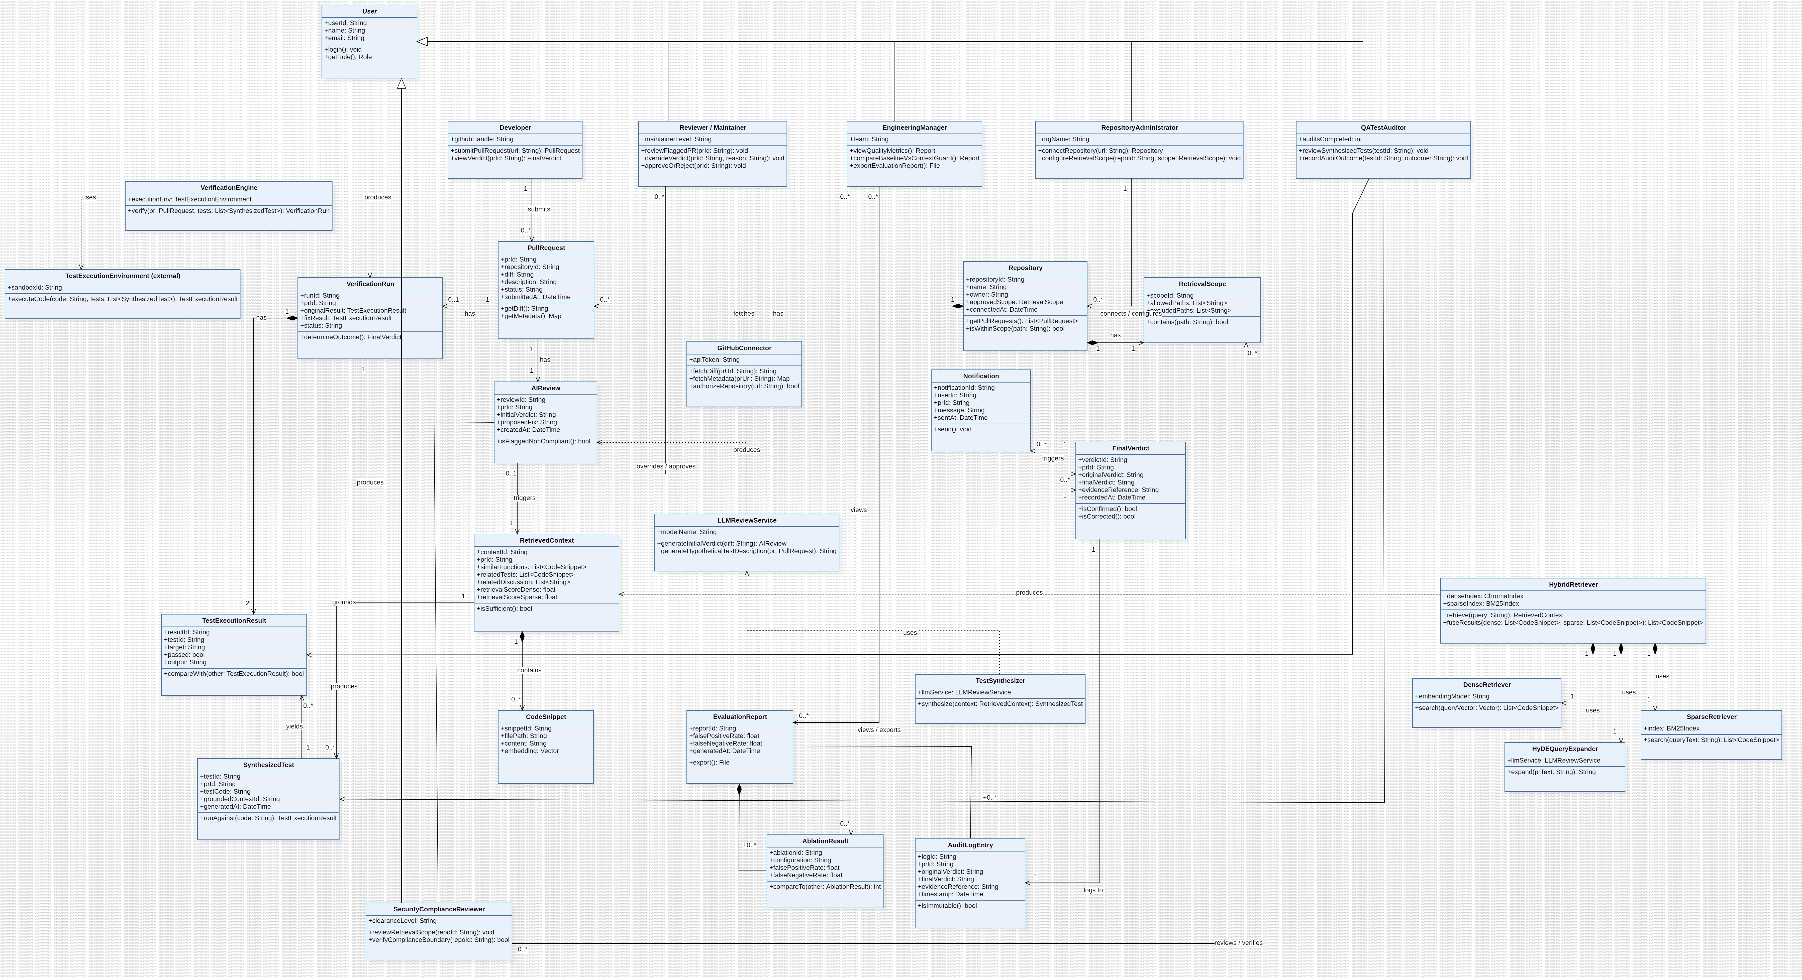
Fig. 1 — ContextGuard Class Diagram

Explanation of Class Diagram:

The class diagram represents the main classes and their relationships in ContextGuard, a repository-context-aware verification layer for reliable LLM-based code review. The system is designed to help re-verify an AI reviewer's own verdict on a GitHub pull request by grounding it in the actual context of the repository.

The User class is the parent class for different types of users such as Developer, Reviewer/Maintainer, Engineering Manager, Repository Administrator, QA Test Auditor, and Security Compliance Reviewer. These classes inherit the common properties and functions of the User class.

The Developer interacts with the PullRequest class to submit pull requests. The Repository class stores information about repositories and is associated with multiple pull requests. The Repository Administrator manages repository information and retrieval settings through the RetrievalScope class.

The AIReview class represents the initial AI-based review process. It is generated for a pull request and, when flagged as non-compliant, triggers RetrievedContext to store the relevant code context. The RetrievedContext contains multiple CodeSnippet objects representing pieces of code, tests, and discussion retrieved from the repository.

The HybridRetriever is responsible for retrieving relevant code from the repository. It uses DenseRetriever, SparseRetriever, and HyDEQueryExpander to improve the retrieval process. The LLMReviewService uses a language model to generate the initial review and to help expand queries for retrieval.

The system also contains a testing and verification module. TestSynthesizer generates tests using the retrieved context. VerificationRun manages the execution of these tests, while VerificationEngine uses the external TestExecutionEnvironment to execute the code. The resulting information is stored in TestExecutionResult and is used to generate a FinalVerdict.

The EvaluationReport and AblationResult classes are used to evaluate the performance of the system. AuditLogEntry records important system activities, while Notification is used to communicate important results to users.

Thus, the class diagram shows how the different users, repository components, AI components, retrieval modules, and testing modules work together to provide reliable, evidence-backed verification of pull request reviews.

